Chapter 10, Solution 50.

Using Fig. 10.95, design a problem to help other students to better understand source transformation.

Although there are many ways to work this problem, this is an example based on the same kind of problem asked in the third edition.

Problem

Use source transformation to find v_{o} in the circuit in Fig. 10.95.

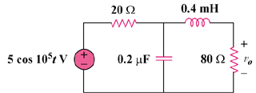

Figure 10.95

Solution

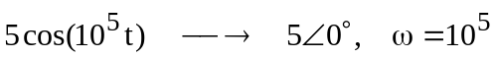
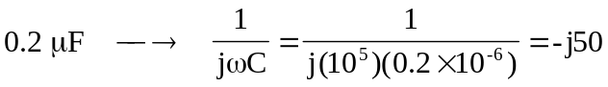

After transforming the voltage source, we get the circuit in Fig. (a).
(a)
80 
0.250 A
-j50 
+
V_{o}
−

20 
j40 

Let 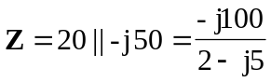
and 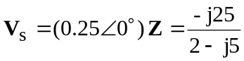

With these, the current source is transformed to obtain the circuit in Fig.(b).
(b)
80 
j40 
V_{s}
+
−
Z
+
V_{o}
−

By voltage division,
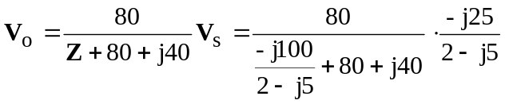
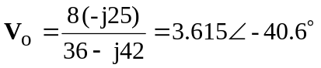
Therefore, 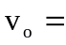 3.615 cos(10⁵ t – 40.6) V

